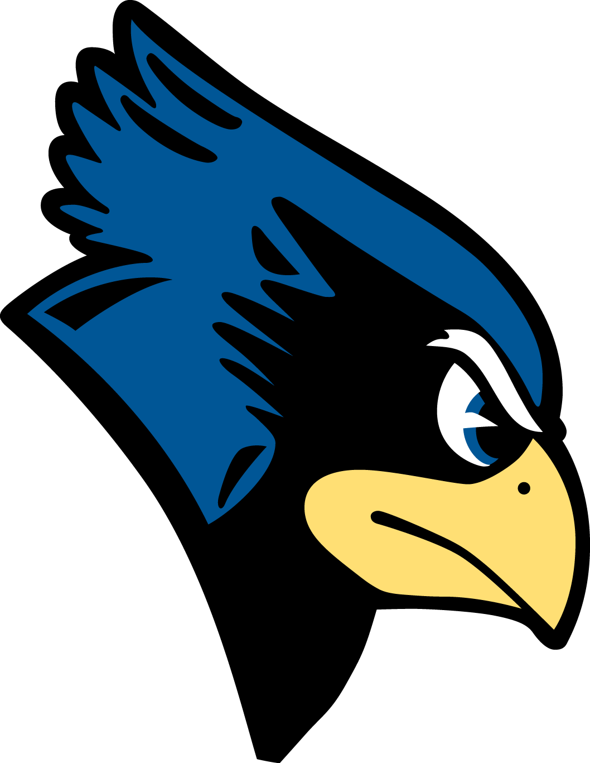 Kenwood High School’s Reopening Information 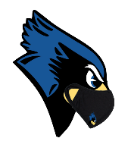
Daily Schedule: 7:45 am-2:15 pm
Introductory statement: Our goal is to create a safe, welcoming, and effective environment for everyone- virtual students, hybrid students, and staff members.
Arrival & Dismissal Procedures:  ALL students will wait outside (rain or shine) until 7:25am when doors open- students enter through designated doors. Bus riders enter through bus loop doors. Parent/Guardian and walkers enter through cafeteria.  If parent/guardians driving students, please drop your students off between 7:25 am-7:40 am.  If you arrive early, please hold your student in your vehicle until 7:25 am. Please do not wait in a parking space as every parking space on campus is reserved for a staff member or student drive.  Students will be dismissed from 4th period at 2:15pm. Students are encouraged to leave from exit door closes to their 4th period class. Building will close to all students at 2:30pm. Student athletes will report to their designated locations for practice/games at 2:30pm. Coach class and after school clubs will take place virtually as scheduled. | Face Covering:  - Face coverings are required for all persons in a BCPS facility or vehicle as well as on BCPS property. Face coverings are required during transportation to/from school on a bus as well as outdoors on campuses. Face coverings should cover a person’s mouth and nose at all times.  - Each school, office, and school bus will have a supply of disposable face coverings for students and employees who forget their face covering or whose face covering becomes soiled or damaged.
Screening & Stay Home When Appropriate:  - All employees and students are expected to screen themselves daily for symptoms of COVID-19.  - Remain home if you have symptoms, confirmed COVID-19 illness, had recent contact with a person with COVID-19 and/or awaiting test results.  - Parents will receive a screening checklist and magnet with the screening practices. | Social Distancing:  - Classroom furniture is arranged to provide 6-feet separation between students and staff, when possible.  - Reduce gathering of students in any area – refer to changes in arrival and dismissal procedures and movement in the hallways.  - Stairwells in the building have been designated as up only or down only.  - Markers are on the floor in hallways to promote students staying to the right when traveling to classes.
Hand Hygiene:  - Times for handwashing or use of hand sanitizer to include before and after meals, upon arrival to schools’ offices and home, before and after use of any shared items, after use of the restroom, after sneezing/coughing and other time hands are contaminated. | Breakfast & Lunch:  All students eligible for meals at no cost.  Bus riders will eat breakfast in the auditorium. Parent/Guardian drop off and walkers will eat breakfast in the main cafeteria.  Lunch will be offered in the cafeteria during 4 assigned lunch periods- A, B, C, D as scheduled through the academic content areas. Social distancing guidelines of 6 or more feet at mealtimes will be followed, and additional health and safety precautions will be implemented during lunch periods. Students will pick up a bagged lunch and then proceed to their assigned seat. Students can bring their own lunch if choosing to do so. Vending machines and snacks will not be available. Students must be in the cafeteria during their assigned lunch and may not be in a classroom, the library, gym, locker room or office space.  Masks can only be removed while eating breakfast and lunch. When finished, masks must be put back on.
Supplies & Devices:  - Wear a mask (a backup is helpful), charged device and charging cord, filled water bottle, backpack with basic school supplies (binder, pen, pencil), headphones, lunch (optional: free lunch available to all). We also recommend bringing a jacket that will allow you to comfortably be outdoors at various points during the school day, including during some classes and lunch.  - Students will need to complete the BCPS Health Attestation Form and bring to school on the first hybrid day of each month. This form MUST be brought to school for the first day of hybrid learning and turned in to your first period teacher. | Visitors:  - To visit a BCPS school, visitors must have an appointment.  - Visits will be conducted remotely or outside, whenever possible.  - If an indoor visit is required, visitors will be required to wear a face coverings and practice social distancing.  - The number of people admitted to the building will be limited.

